User Testing Plan
"Roadies" Global Roadside Application for Android
Our roadside assistance application is currently in the early stages of prototype development. In this user testing documentation, our group hopes to demonstrate the potential this application has in being user friendly, intuitive and effective. We have chosen to demonstrate our prototype on a mobile phone running the Android operating system.
Summary:
Our roadside assistance application, while comprehensive, has only a few functioning sections in order to demonstrate a working prototype. We were interested in taking a full section of the application to completion, from initial login until issue resolution.
Our first screen consists of the login screen. This will be for existing users to sign in with their unique profile and settings. The interface design is still quite rough, however this initial layout is in keeping with what we would like to achieve.
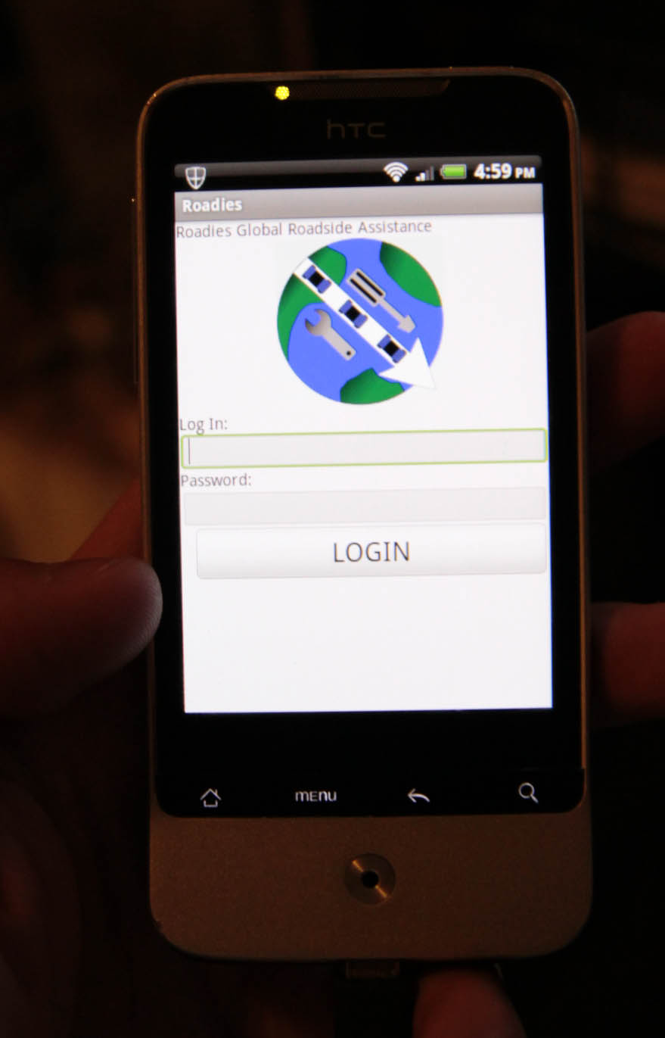

Our second screen will take us from login to the overall dashboard. Here, there will be multiple icons available for user selection. These icons will represent different issues or problems that the application will then handle. We have chosen to implement the "Repairs" function, while the remaining icons will be expanded upon in the future. Many will follow the same form and function of the "Repairs" button, resolving a potential issue by selecting the criteria the user wants to address.
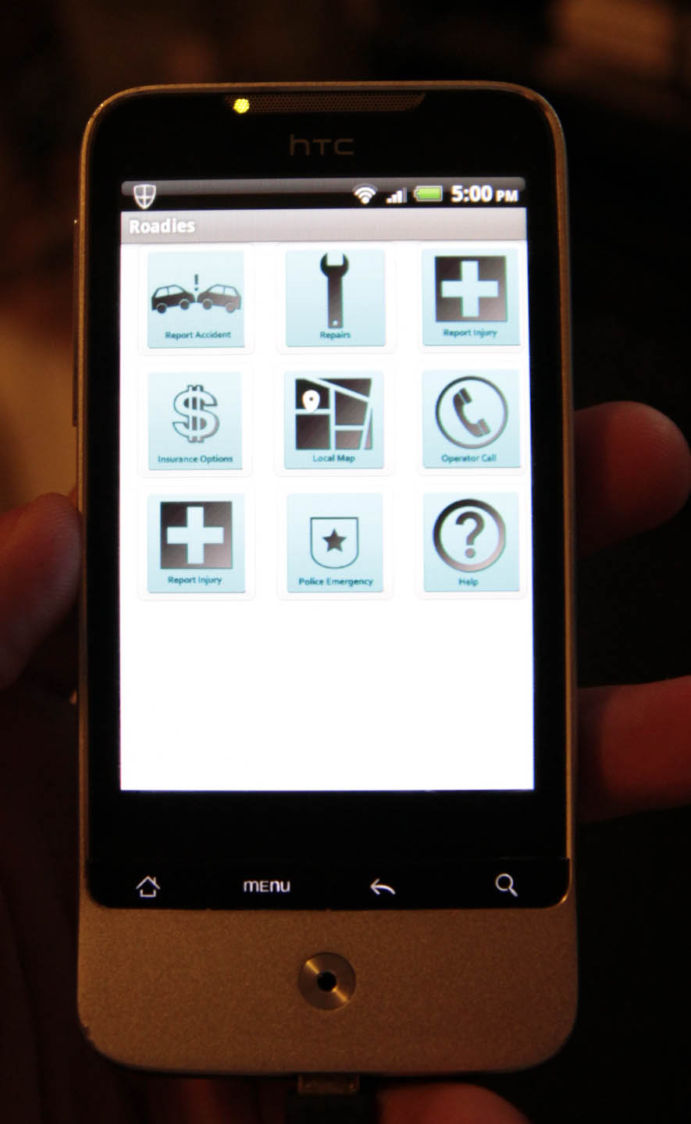

Within the "Repairs" screen there exist a number of potential problems that users can choose to access and resolve. These may include break errors, engine trouble, tyre problems and battery issues. Naturally, these would be expanded upon further when a full application is created.

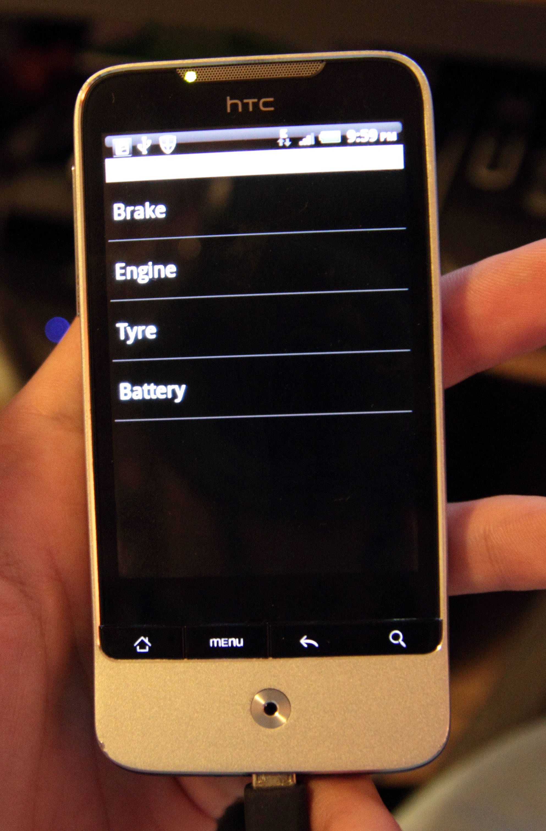

Again yet to be expanded, within the first selection of the repairs screen, there is a separate submenu. This submenu will be dependent on the initial selection criteria, although at this point the selections include lagging, engine failure and brake oil leakage. Naturally there will be a sub-menu similar to this one on each problem screen, letting the user tailor their response.
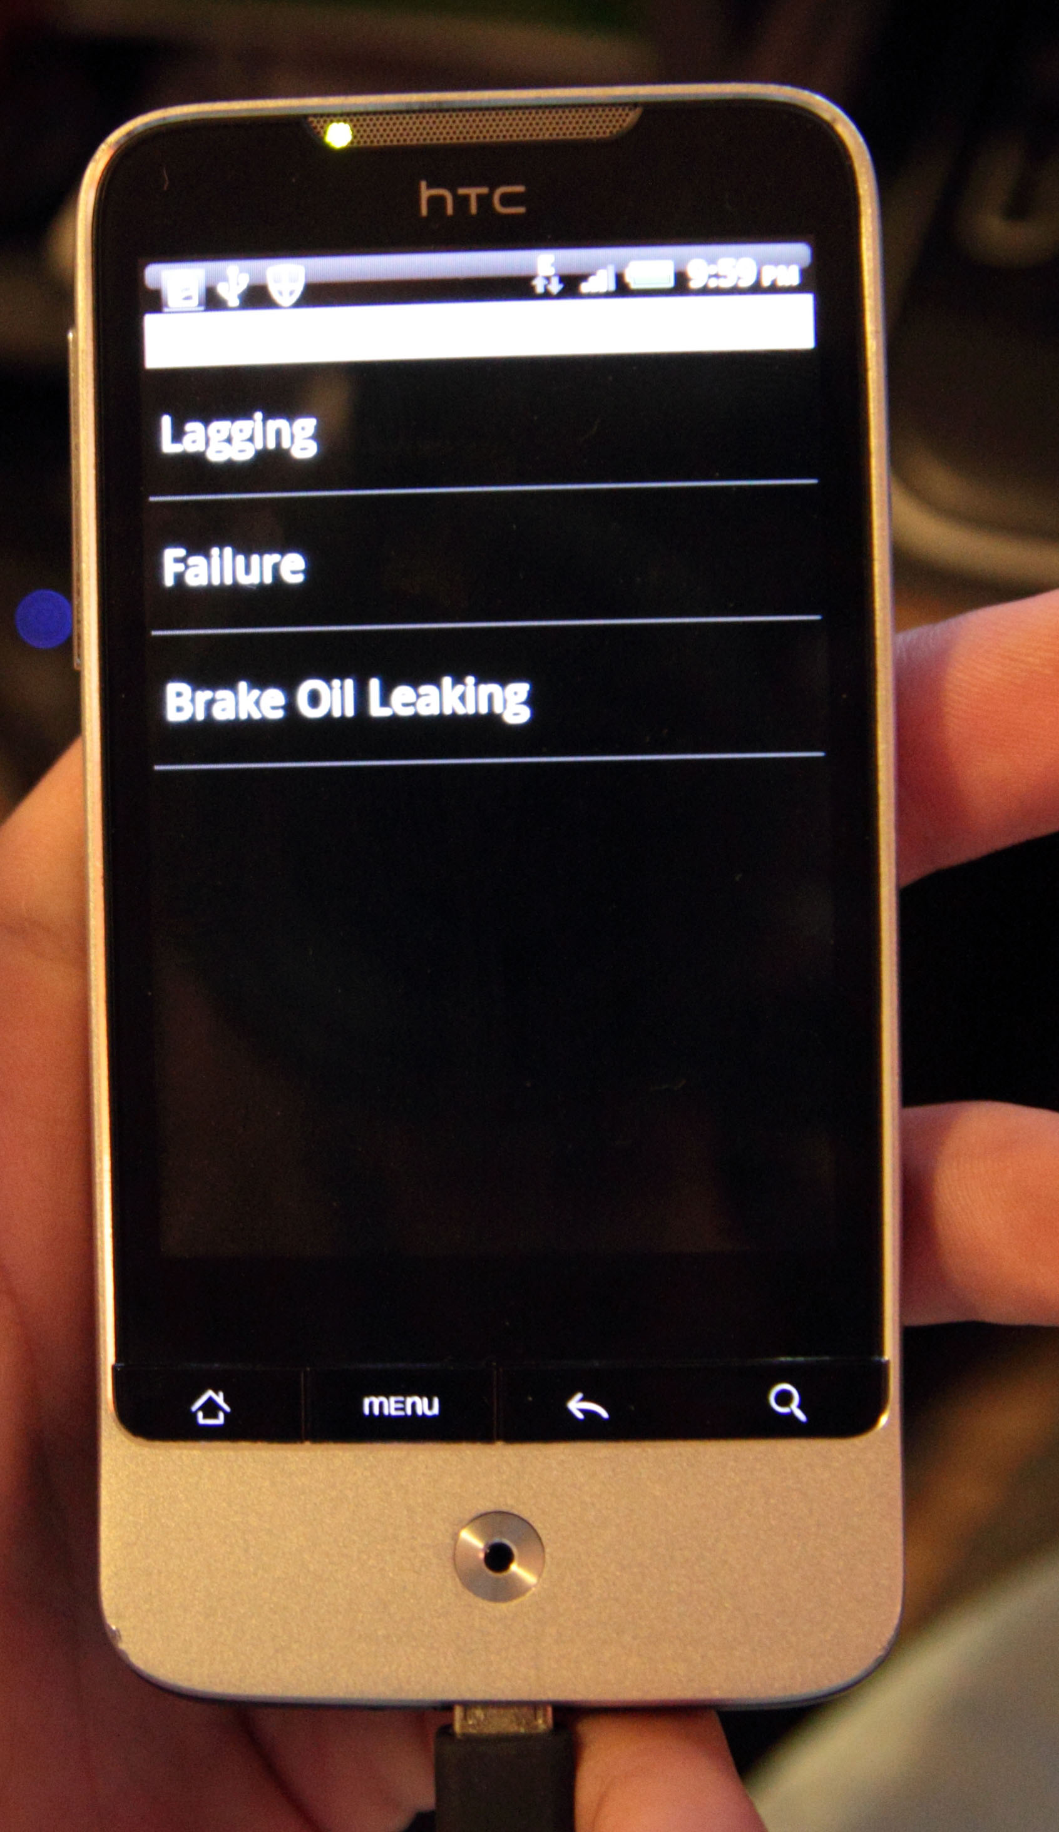

The final screen of our prototype is the submit screen. This will send whatever issue the user has chosen to the Roadies web server. This will most likely be a similar final screen for other sections of the application. For our current test, this screen also displays the location data in longitude and latitude form, which is caught by the GPS device on Android phone.
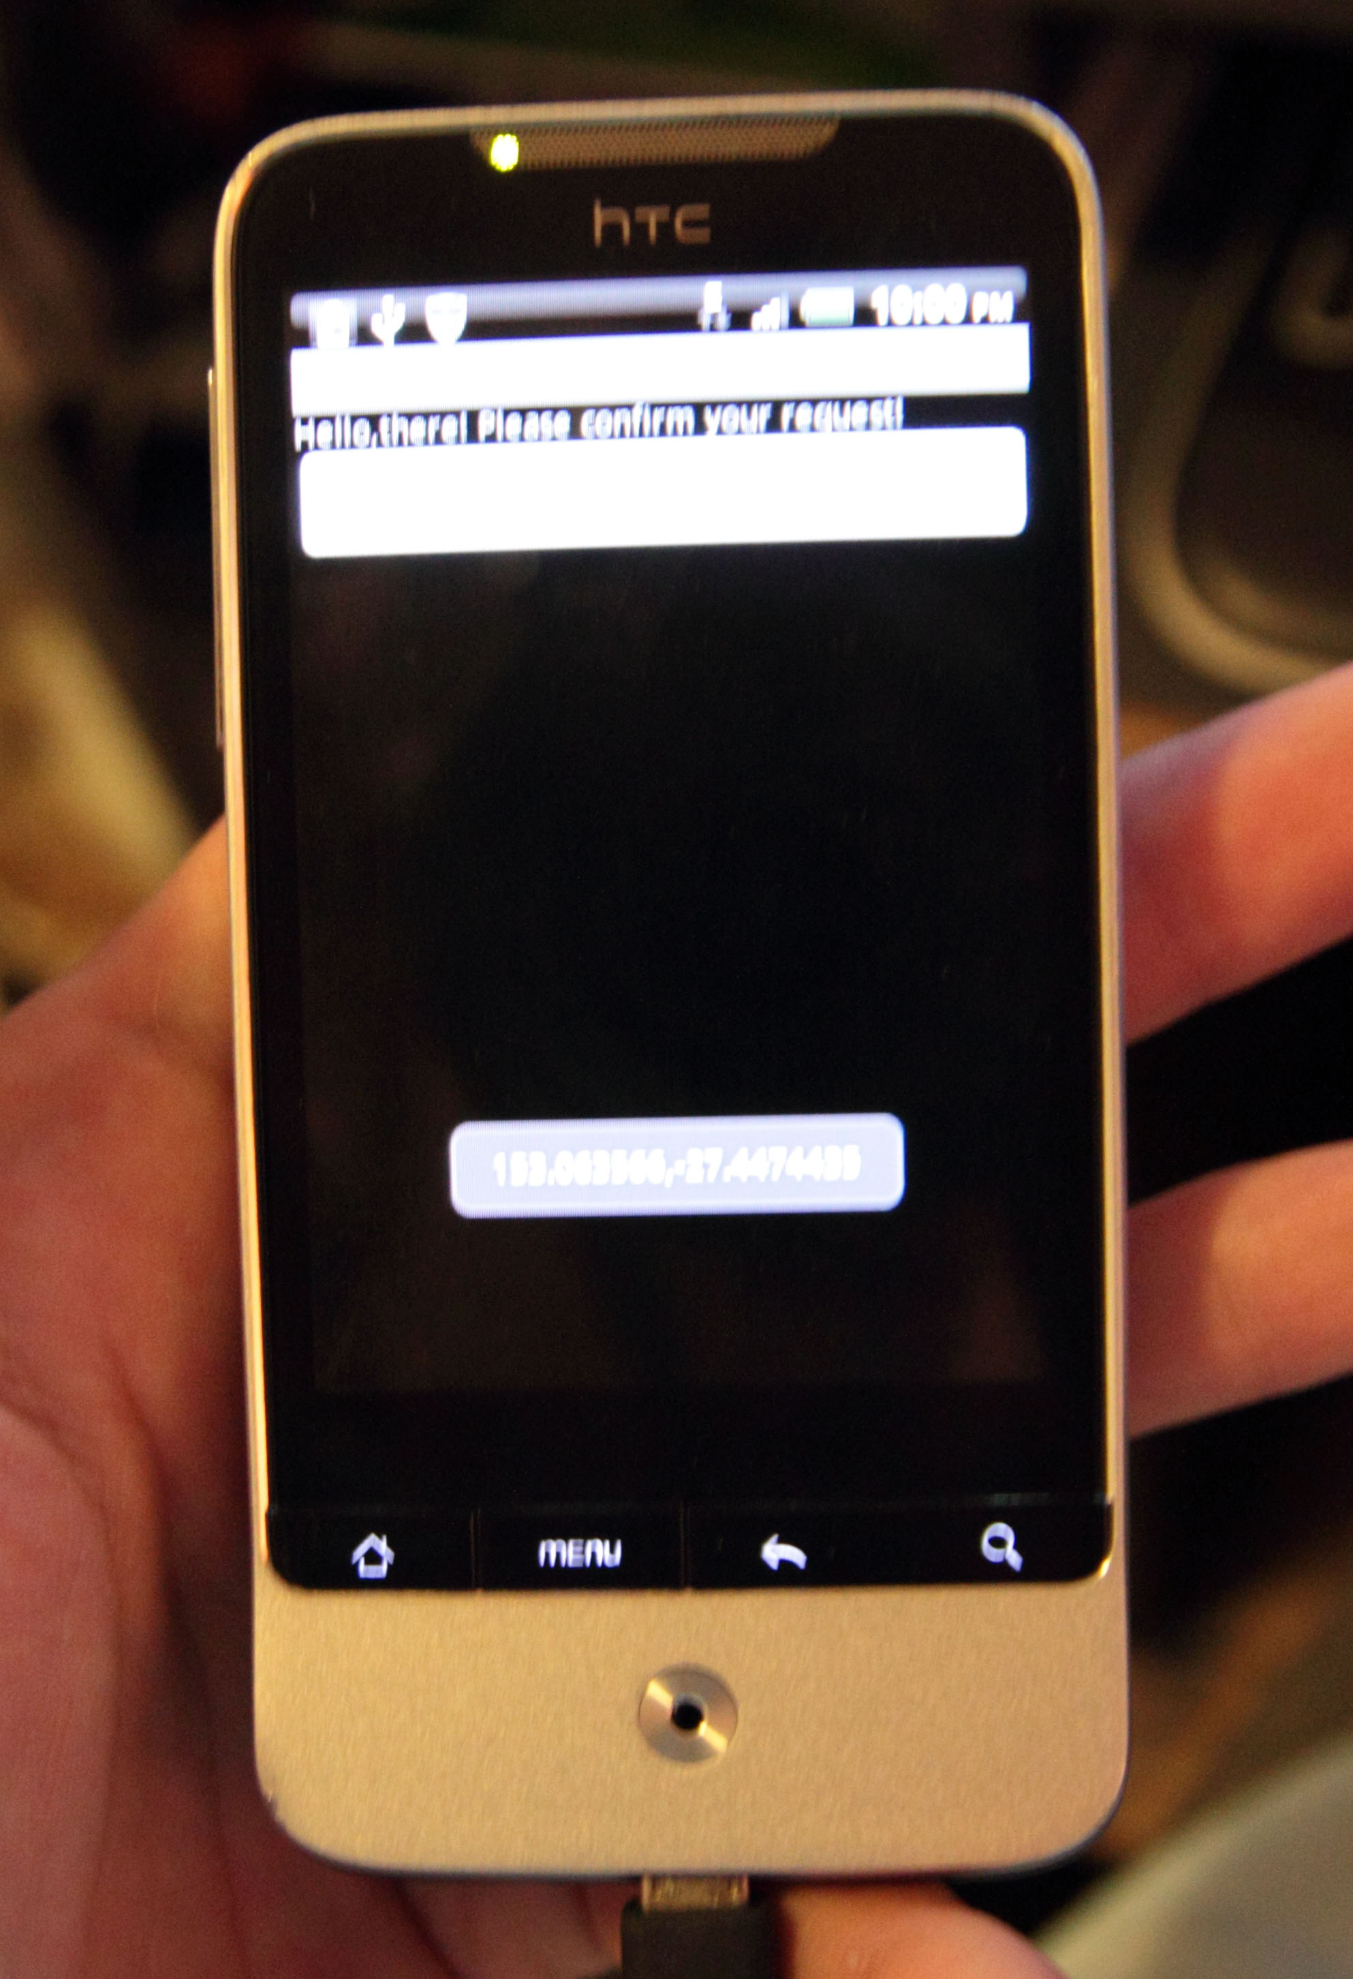

This is a quick overview of the general layout of our roadside application. We believe it should be sufficient to get a general idea of the flow of the application for initial stages of testing.
Scenarios
As our application is still in its early stages, it is difficult to run through potential scenarios as there are a very limited number of things that can happen when testing very few situations. Our currently running piece of software is limited to reporting accidents.
Scenario 1:
Traffic accident - Emergency
In this scenario, the user has just met with a serious traffic accident where someone is critically injured. The speed at which the user is able to navigate the interface and lodge an emergency is of critical importance. We will get the users to register the issue as fast as possible. As there is no emergency server feature at the moment, users will be told to use access the emergency button on the dashboard.
Scenario 2:
Traffic accident - Brake Failure
This scenario is made to simply register an accident and trade contact information, as well as insurance details. This is less of an emergency than scenario 1 and as a result, time is less of a factor. Registering the accident and contacting relevant services with ease is the greatest importance here. This test will be measured at a leisurely pace.
Metrics:
Naturally running our tests with some set usability metrics will give a greater understanding of what is needed to improve our application. The metrics we have chosen to use in our testing include:
How long the user testing took?
An idea of how long it takes average users to navigate and understand our interface, as well as resolve any potential problems they may have. Naturally users will have to log into the initial screen when using the application.
How often outside assistance was needed?
An important metric, as our application must run without assistance in real life situations. This will determine how easy/hard it is to understand our application and run it quickly.
Errors
This is to see how many times the program crashes or has any other unexpected errors.
Number of steps taken to complete task
How many screens users will have to go through, or how often they will backtrack. We will assign tasks to users in order to see how long on average it will take to complete. This will be measured against what we consider an appropriate length of time and measure the outcome.
User test results
User test 1
Male // 56 // Technologically Proficient (familiar with mobile applications) // Non-driver
Scenario 1 Metric Results:
Time taken from login screen until accident submission: 13 seconds
How often assistance was needed: 0 times
Errors: 0 errors
Number of steps/screens taken to complete: Login screen -> Dashboard -> Problem screen -> submenu -> submission. 5
Scenario 2 Metric Results:
Time taken from login screen until accident submission: 18 seconds
How often assistance was needed: 0 times
Errors: 0 errors
Number of steps/screens taken to complete: Login screen -> Dashboard -> Problem screen -> submenu -> submission. 5
Comments:
The application was easy to understand and very simple. The user mentioned that it is very one way and as a result doesn't have much room to manoeuvre or much room for error. The overall design of the interface was easy to understand, though needs fleshing out. There was no need to ask for assistance as the application itself was very straightforward. The user wears glasses and mentioned that the dashboard needs to be much larger in order for him to see the icons and the text better. As it was, it was a little hard to view all the available options.
All in all a positive response, the time in which the application took to run from start to finish was within accepted norms. The user particularly liked the map co-ordinates at the end of the submission, though naturally a working map would have been preferable.
User test 2
Female // 52 // Technologically Basic (use of basic software, non-mobile) // Driver
Scenario 1 Metric Results:
Time taken from login screen until accident submission: 25 seconds
How often assistance was needed: Once
Errors: 1
Number of steps/screens taken to complete: Login screen -> Dashboard -> Problem screen -> submenu -> submission. 5
Scenario 2 Metric Results:
Time taken from login screen until accident submission: 25 seconds
How often assistance was needed: 0 times
Errors: 0 errors
Number of steps/screens taken to complete: Login screen -> Dashboard -> Problem screen -> submenu -> problem screen -> submenu -> submission. 7
Comments:
The first test had a few issues as the phone which we were using to test the application froze halfway. As a result, there was need for assistance in order to put the application back on track. The time taken as a result was omitted from the test results.
The user, not being proficient with mobile applications, had some trouble understanding the dashboard screen and the options therein. A question came up in the submenu screen as some of the options were not working at the time.
In the second test, the speed at which the user tested the application was much faster thanks to familiarity from the first test. There were no errors or questions asked, though the number of steps taken to achieve the end goal were increased as the user wanted to know what other options there were in our application.
Overall the user eventually understood the purpose of the application and how it works. Comments were to finish off the menu and sub-menu sections as they are currently not working. Making the dashboard menu larger was also added. After explaining how the crash would actually be registered, a suggestion was made to include some sort of camera in which to take a photo of the other drivers number plate and license. This idea was not fleshed out in detail though.
User test 3
Male // 23 // Technologically Proficient (very tech savvy) // Driver
Scenario 1 Metric Results:
Time taken from login screen until accident submission: 11 seconds
How often assistance was needed: 0 times
Errors: 0 errors
Number of steps/screens taken to complete: Login screen -> Dashboard -> Problem screen -> submenu -> submission. 5
Scenario 2 Metric Results:
Time taken from login screen until accident submission: 14 seconds
How often assistance was needed: 0 times
Errors: 0 errors
Number of steps/screens taken to complete: Login screen -> Dashboard -> Problem screen -> submenu -> submission. 5
Comments:
The first and second test for this user were very fast and identical in nature. The user is very technologically proficient and as a result is familiar with a wide variety of android based applications. There were no issues of any kind on either test run.
A wide range of feedback was given on the application. Discussion was made around the simplicity of the application and how bare the current prototype was. Naturally, it was explained that all sections would be running in a finished product. The user mentioned that the menu and submenu could be displayed a lot like the dashboard, which would be in keeping with the overall design. The final submission screen was also too bare and the user did not feel like he had gone through any process aside from the co-ordinate logging. Despite this, the user explained that the overall application and flow of the menu was well designed. The overall idea of a roadside application was also discussed and the user expressed great interest in this potential application. The user mentioned that previous car crashes he was involved in were very complex in nature and having something to simplify the process could be very useful.
In conclusion the application ran well, with feedback that it needs to be improved on in content but not so much in design.
User test 4
Female // 27 // Technologically Proficient (familiar with mobile applications // Driver
Scenario 1 Metric Results:
Time taken from login screen until accident submission: 14 seconds
How often assistance was needed: Once
Errors: 0 errors
Number of steps/screens taken to complete: Login screen -> Dashboard -> Problem screen -> submenu -> submission. 5
Scenario 2 Metric Results:
Time taken from login screen until accident submission: 21 seconds
How often assistance was needed: 0 times
Errors: 0 errors
Number of steps/screens taken to complete: Login screen -> Dashboard -> Problem screen -> submenu -> submission. 5
Comments:
Our final user was quite proficient in navigating our application. The first scenario prompted some assistance on the first 'problem' menu, as the bottom 2 buttons were dead links and not selectable. I informed the user that only the top button can be operated for now. This aside, most of the metric results were consistent with the previous 3 users. The second scenario had fewer errors and the user was able to navigate through to the end in 21 seconds.
Some feedback included a nicer looking interface, as well as larger menus. Although just a prototype, the user suggested some refinement to the login page, just to tidy the spacing of the buttons and the logo up a little bit. As the user often uses mobile application, her suggestions were to make sure that this application brings original content across instead of just a re-hash of pre-existing ideas. The concept of making the application global was well received, as well as automating many services within the application, such as contacting authorities.
Conclusion - Overall findings and improvements:
Conducting these user tests gave us some very important feedback as well as some ideas for future improvement.
The comments that were repeatedly made by users included:
1. Cleaner interface;
2. A better fleshed out menu and submenu;
3. Larger dashboard;
4. More choice inside the submenu's so that the user can identify the exact problem he or she has encountered;
5. Making the final submission map more interactive.
Considering these comments, it is clear that a better fleshed out prototype is in order, so that more scenarios can be made and observed. As this is not a final product, many of these user comments would naturally be put through to the final implementation and left out of the prototype phase.
On our side, it is understood that the speed at which users navigated the application was fast and the lack of errors in its use was also favourable. The relative lack of assistance needed to guide the program was also very good, as well as the steps taken in order to submit a roadside issue.
Improvements that will be made will include the comments made by the users, as well as going back and tidying the interface as well as adding more options to the dashboard. As for future testing, again having more items to test would be great for increased feedback, alongside testing a wider number of scenarios.
In conclusion, the user testing went according to plan, with no major glitches or problems encountered. Our prototype was successful in what it aimed to do, with little need for explanation.

